* All of this work was done in SAS and modelled after some of the help code that Dr. Craig gave me. Some of the conclusions might be slightly different than the work in R.

**AM analysis**

1. Test the full vs reduced covariance structure
   1. Full: response = side*task + (1 | side:participant) + (1| task:participant)
   2. Reduced: response = side*task + (1| task:participant)

Residual / BIC analysis:

* BIC full: 1065.64, BIC reduced: 1064.17

* From the above plot, looking at the top left plot it appears that there are some outliers for the residual. This indicates that there might be an issue within the data itself. Hence, we can use a log transform on the response to minimize this effect.

Results from the log transform:

* BIC log_full: 86.09, BIC log_reduced: 125.40

* Logging the response is clearly the correct approach, since it leads to normal residuals (This is important with hypothesis testing and lack of fit tests).

From the above, the best covariance structure to use is the full model with the log transform on the response.

* Model: log(response) = side*task + (1 | side:participant) + (1| task:participant)

1. Task comparison (Tukey Test / Contrast tests)

* {1: 5ml, 2: Pudding, 3: Effortful Swallow, 4: Mendelson}

* From the above, for AM we get the significant differences being between tasks 1&3, 1&4, 2&4, 3&4
* Water is different than the rehab swallows, and Pudding is different than the mendelson. As expected, the es and mendelson are different.

The next step is to evaluate the average(5ml, pudding) against the rehab swallows (ES, MM)

* From the above the average(5ml, pudding) are different than the rehab swallows.

**BD analysis**

1. Test the full vs reduced covariance structure
   1. Full: response = side*task + (1 | side:participant) + (1| task:participant)
   2. Reduced: response = side*task + (1| task:participant)

Residual / BIC analysis:

* BIC full: 237.91, BIC reduced: 235.71A diagram of a function

  Description automatically generated with medium confidence
* From the above graph there are some outliers, which could indicate that the good-side bad-side phenomenon is happening again.
* Use the log transform to see if this changes anything.

Results from log transform:

* BIC log_full: 7.07, BIC log_reduced: 5.33
* Diagnostics for the full log model

* Diagnostics for the reduced log model

Based on the above, the appropriate model to use would be the reduced model. It doesn’t appear that the participant’s good or bad side has a significant effect on the BD model.

The appropriate model to use is:

* Model: log(response) = side*task + (1| task:participant)

1. Tukey test + contrast evaluation of BD model

* Based on the above, the significant differences are with tasks 1&4, 2&4, 3&4
* Water and Mendelson are different, pudding and Mendelson are different, ed and Mendelson are different

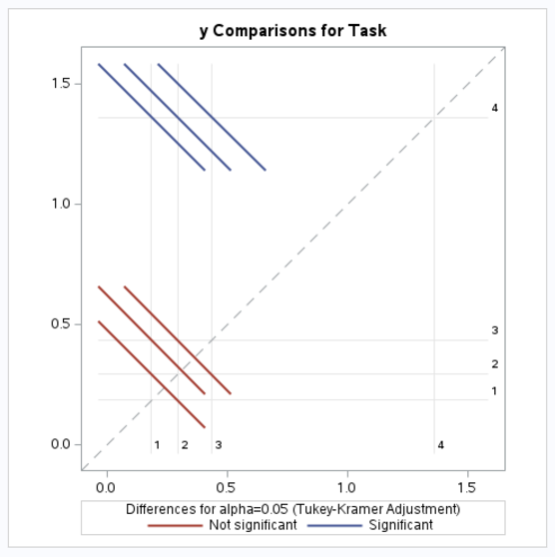

For the contrasts:

* The average between water & pudding isn’t significantly different than es. The average is however different than Mendelson.

**TTP Analysis**

1. Test the full vs reduced covariance structure
   1. Full: response = side*task + (1 | side:participant) + (1| task:participant)
   2. Reduced: response = side*task + (1| task:participant)

Residual / BIC analysis:

* BIC full: 151.64, BIC reduced: 154.60

* The left is the residuals for the full mod, the right is the residuals for the right mod, clearly there is an outlier in the data. Hence let’s log transform to improve the fit.

Residual / BIC analysis log data:

* BIC log_full: 46.78, BIC log_reduced: 55.39

* The left is the full model, the right is the reduced model. Overall, the full model is the better fit in that one of the patient’s sides significantly impacts the TTP.

Hence the model / covariance structure we will use is:

* Model: log(response) = side*task + (1| task:participant) +(1| side:participant)

1. Tukey / Contrast analysis

* From the above, the significant differences are: 1&2, 1&3, 1&4, 2&4
* Water is different than pudding, ES, and Mendelson. Pudding and Mendelson are different.

Contrasts:

* The average of water and pudding is different than the rehab swallows.

**AD analysis:**

1. Test the full vs reduced covariance structure
   1. Full: response = side*task + (1 | side:participant) + (1| task:participant)
   2. Reduced: response = side*task + (1| task:participant)

Residual / BIC analysis:

* BIC full: 660.39, BIC reduced: 688.07

* No logging is needed for the response, since this data is standardized, ultimately the residuals are random and normally distributed. In this case, similar to the AM analysis, some of the participants might have a bad side, hence we will use the full model:
  + response = side*task + (1 | side:participant) + (1| task:participant)
* If we take the log of the model we will get the following for the residuals

* BIC model full: 33.95, BIC model reduced: 72.67
* We will still use the original full model for the analysis.

1. Tukey / Contrast analysis

* From the above, the significant differences are with task 1&3, 3&4
* Water is different than mendelson and ES. ES and mendelson are different.

For the contrasts:

* The averages between water and pudding are different than the rehab swallows.